TPN Live Dynamic Import by ZiPZAP Computers Limited

What does it do?

It imports a standard text file of information, either CSV or pipe delimited, into a database which holds all the fields to push into TPN Live. Once imported into TPN Live they are immediately viewable and modifiable.

You can default the fields which are not in the file subject to a few rules –

1. If you enter the number of pallets in your file then you must have a field for the weights

2. The BOOK IN service is not supported at the moment

3. Omit field descriptors in the first line (new option to skip this added 27/09/2012)

This screen shows the fields that go into TPN Live –

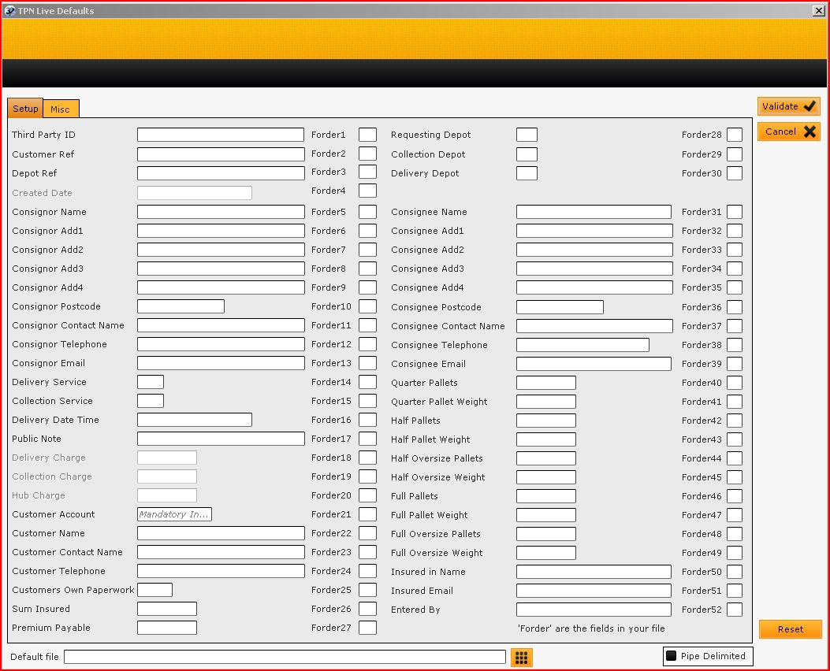

You complete the fields that are not in your file and which need some information in them –

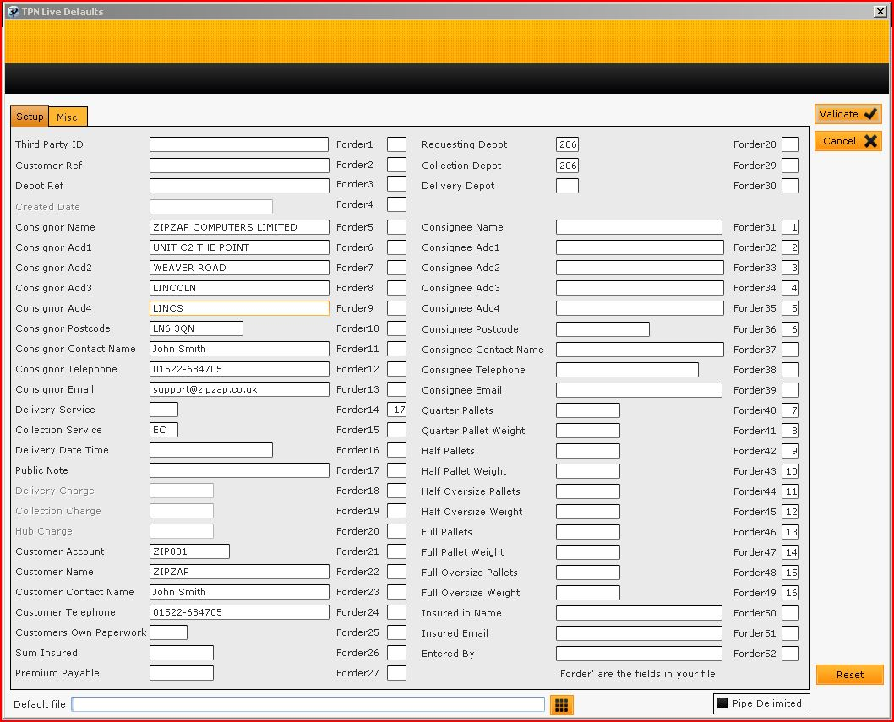

Third party ID can be supplied by the program automatically.

Note the fields marked Forder.

Forder31 will be filled from FIELD 1 in the file.

Forder32 will be filled from FIELD 2 in the file.

Forder17 will be filled from FIELD 17 in the file.

The delivery depot is calculated from the postcode if left blank.

You simply enter the number that corresponds in this field.

You can miss fields that are not going to be imported entirely.

If you are always going to pull in the same file then select it in the field at the bottom.

This is a template for the final data.

You set up the username, password for using the Live system in SETUP/PARAMETERS.

To import the file you now go to ACTIONS on the main menu and IMPORT FILE. Select as appropriate. Once imported you can VIEW the contents and then POST THE DATA.

You can import different formats for a series of accounts.

Note that if you want to dynamically pull in a file and print labels at the same time then you can set up one format to do this. Just add the details in the bottom section of PARAMETERS and then choose the option of POLL on the main screen. All valid jobs will be labelled automatically. Any remaining with faults can be amended and then get printed on the next POLL.

Price – single copy for use in a depot £300.00 plus VAT or single copy for use on a customer site £100.00 plus VAT.